  BARCELO MARINA PALACE (VARADERO)
  
  Number of rooms: 548
  Location / Description Located next to the Gaviota Marina and a short distance from the Ecological Park at Punta Hicacos, this property opened in February 2005 and offers spacious and comfortable accommodation in beautiful landscaped grounds next to a two kilometre stretch of unspoilt white beach.
  Click on the photos below to enlarge
  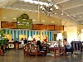 |  | 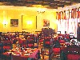 |  | 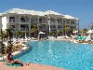
  Rooms 548 rooms, all offering air condtioning, ceiling fan, satellite TV, minibar, safety deposit box (extra cost), ironing facilities, full bathroom, hairdryer, balcony or terrace.
  Local activities beaches, diving, family amenities and watersports.
  General facilities shops, gift shop, car hire, money exchange, beauty salon, indoor games, bike hire, laundry service (charge), parking and spa (charge).
  Sports & fitness facilities swimming pool(s), pool bar, jacuzzi, fitness centre, massage & physiotherapy (charge), tennis courts, sauna, outdoor sports (volleyball, putting green), watersports (windsurfing, snorkelling, aquabikes, catamarans and diving clinic).
  Wining & dining buffet restaurant, a la carte restaurant(s) (3 a la carte dinners per week), cafeteria and bar(s).
  Entertainment theme nights and daily entertainment programme.
  Childrens' facilities childrens' pool, babysitting (charge), organised games, misc supervised services (babyclub 0-5 years and kids club 5-12 years).
  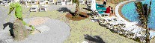
  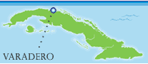
  Free with your
  all-inclusive stay:
  Meals from the selection of breakfast,
  lunch and dinner menus
  Unlimited locally produced alcoholic
  and non-alcoholic drinks .
  All land and watersports as offered
  by the hotel including scuba diving with
  instruction
  Supervised children’s club
  Programme of daily activities
  Entertainment programme including
  live shows and cabaret.

